F13L-AUTOMATIC CLEARING SPECIFIC TO LEDGER GROUPS


This simulation describes how to use T-Code F13L to perform automatic clearing for G/L accounts which are set up as "Clearing Specific to Ledger Groups" in G/L master data.

Note that there are scheduled jobs for F13L which run automatically therefore you normally do not need to perform the steps described in this simulation manually.

Click to continue.

Explanation | Screenshot
[1] F13L is now entered in the Transaction box. | 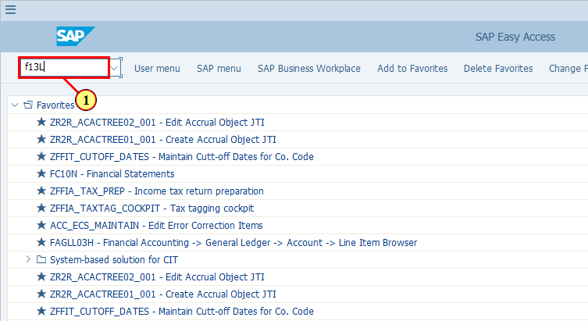
  Normally there are already variants set up for clearing of different set of accounts. You may select your variant as demonstrated in the follow steps.  [2] Click Get Variant... if you already have a variant set up for F13L.  You can also press Shift+F5. | 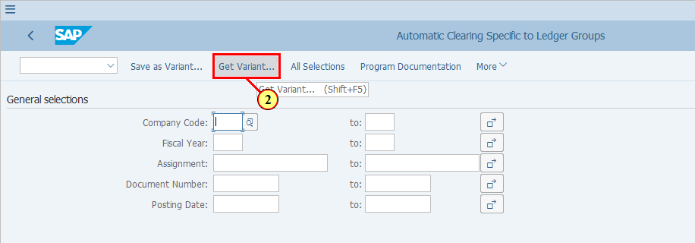
[3] You can use all the available search criteria here. The field Created By is by default already filled with your user name. If you do not want to use it as a filter, click on it and delete it in the next step. | 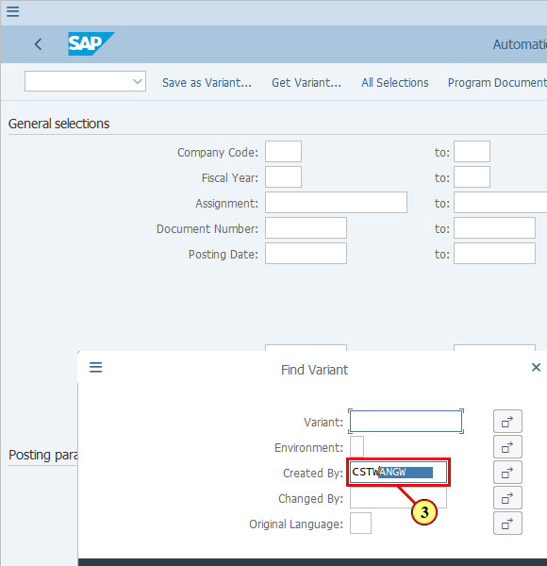
[4] The Created By field is cleared. | 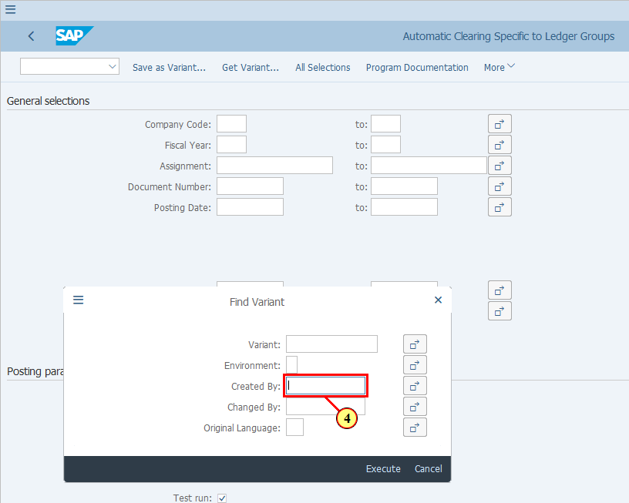
[5] Click Execute .  You can also press F8. | 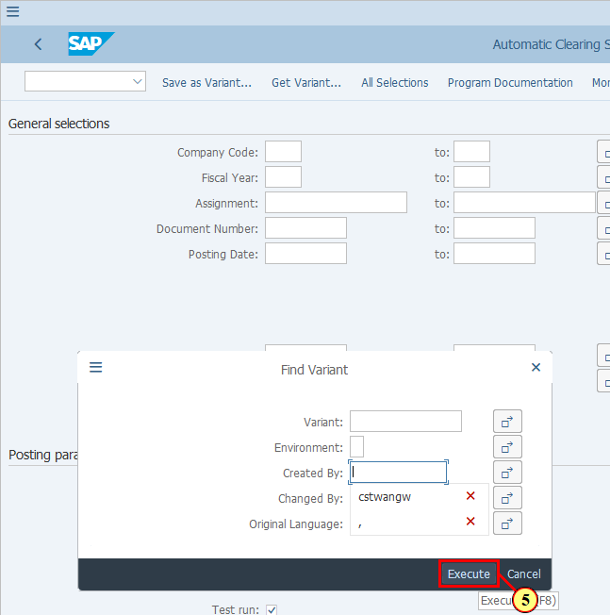
[6] Once you have found your variant, click on it to select it. | 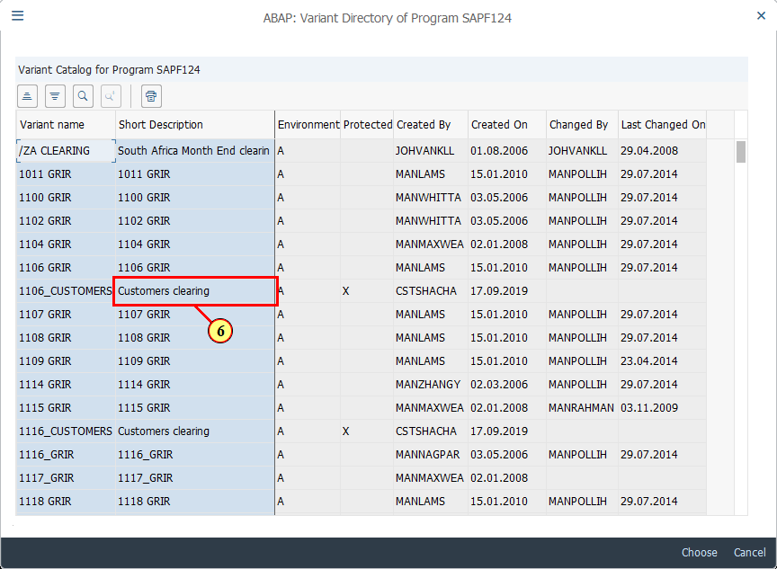
[7] Click Choose .  You can also press F2. | 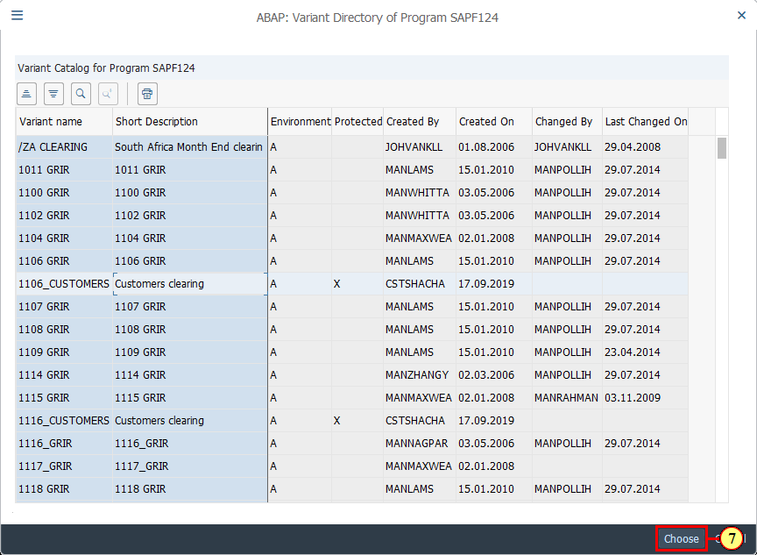
  If you do not have a variant already set up, or you need to have different selections from your existing variant (e.g. in case you need to perform an ad hoc F13L using a specific set of selection criteria), you may follow the next few steps.  Click to continue. | 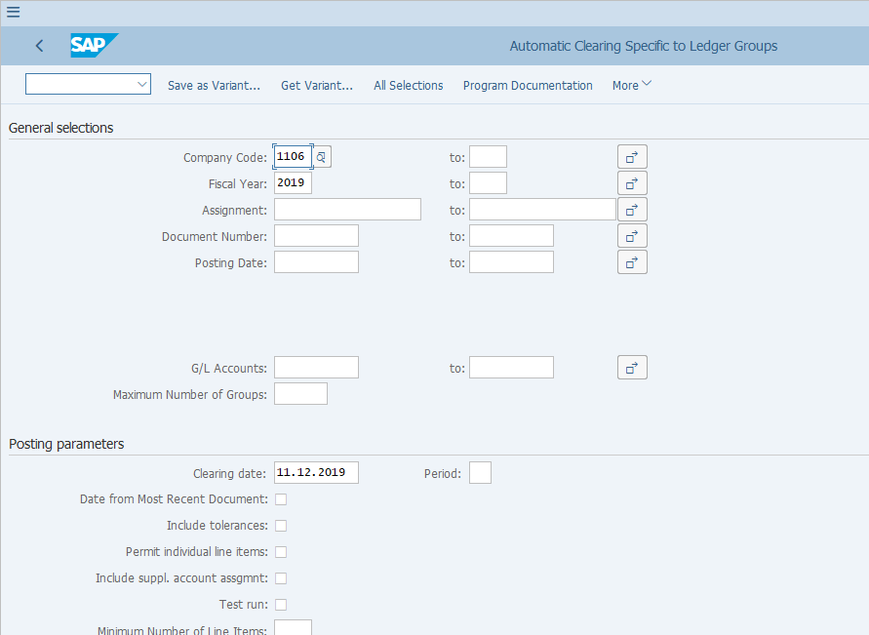
[8] Enter your company code in the Company Code field. | 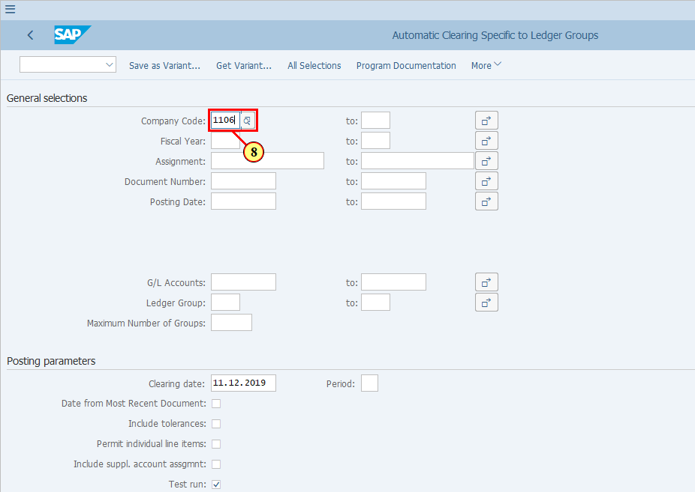
[9] Enter the Fiscal Year or range of Fiscal Year in the Fiscal Year field.  This is the fiscal year in the documents of the line items that you wish to clear, therefor it may be a range from past year(s) to current year. | 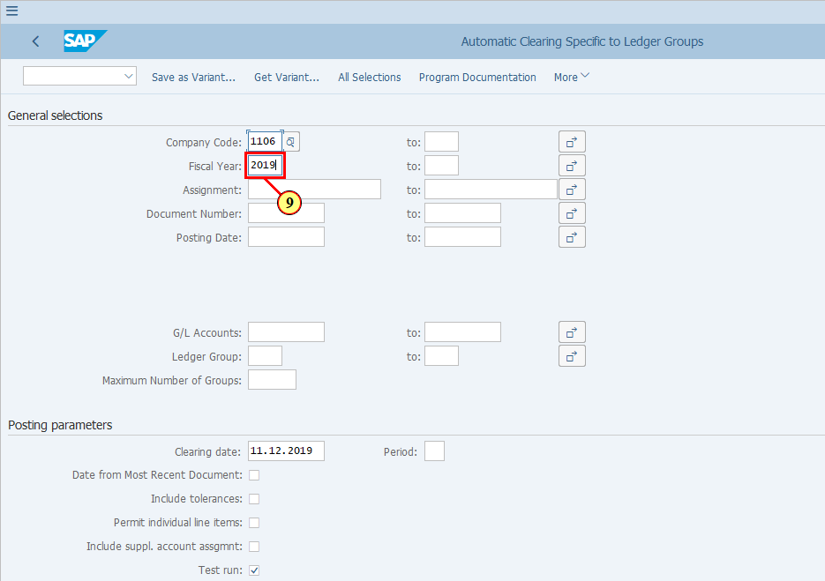
  You may use further selection criteria to restrict the line items that will be selected for auto ledger group specific clearing, such as Assignment, Document number, Posting Date, etc. | 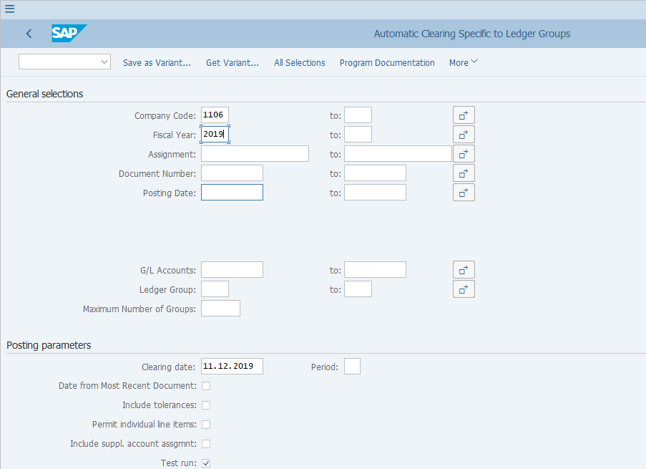
[10] Enter the G/L account or range of G/L account that you wish to clear in the G/L Accounts field. | 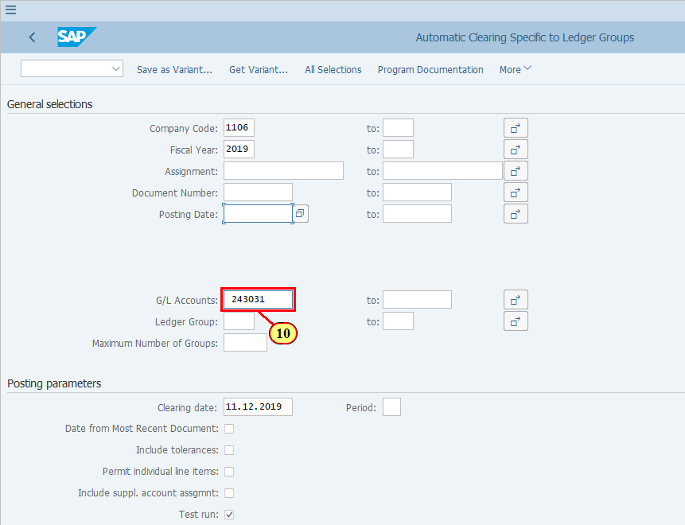
[11] It is critical to fill in the Ledger Group field. | 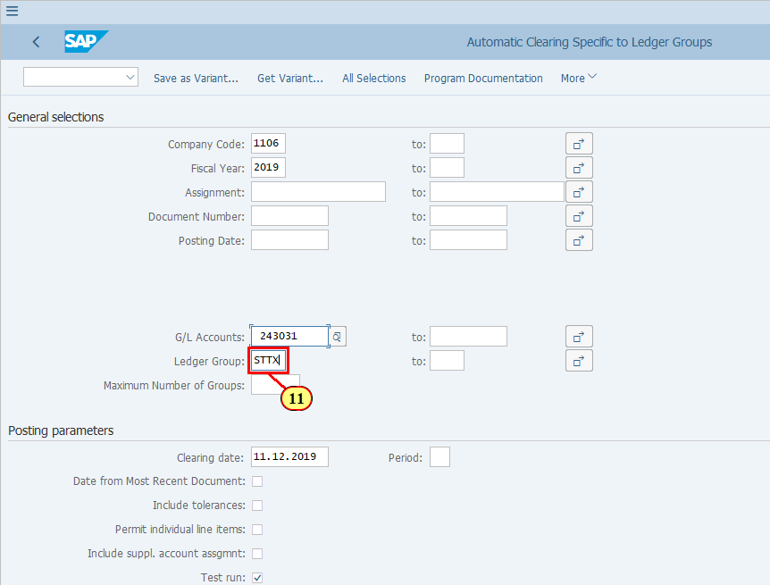
[12] By default the current date is populated in the field Clearing date.  You may need to change it if you wish to make the clearing posting to a specific period which the current date does not fall in, e.g. during month end closing. | 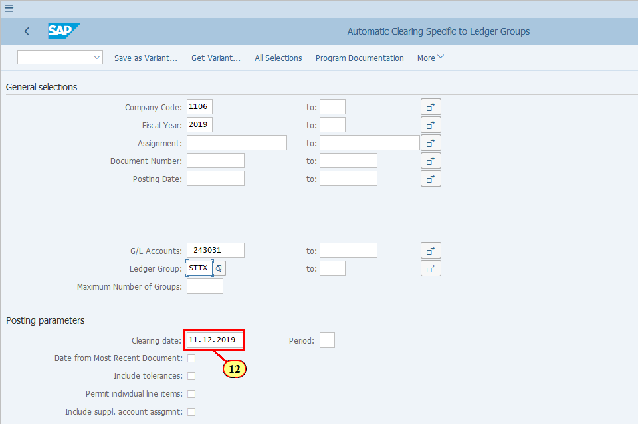
[13] You are recommened to always do Test run before update run.  So make sure you Test run is ticked when you run F13L for the first time with your selection criteria. | 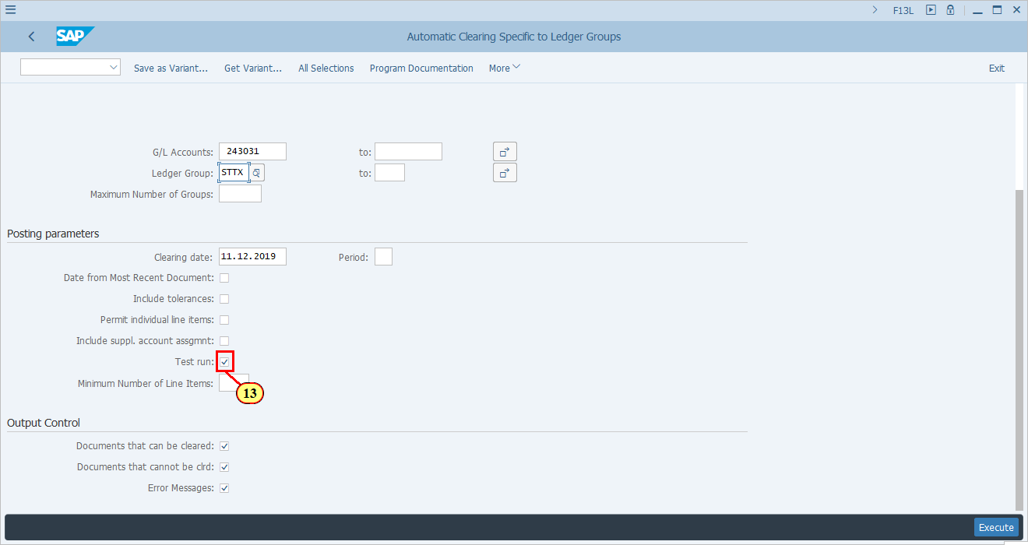
  The Output Control section are automatically ticked like this when you enter F13L transaction. These selections will allow you to see if there's any errors encountered during the execution of the transaction and show you the items that can and cannot be cleared.  It is recommened that you keep these default selections. | 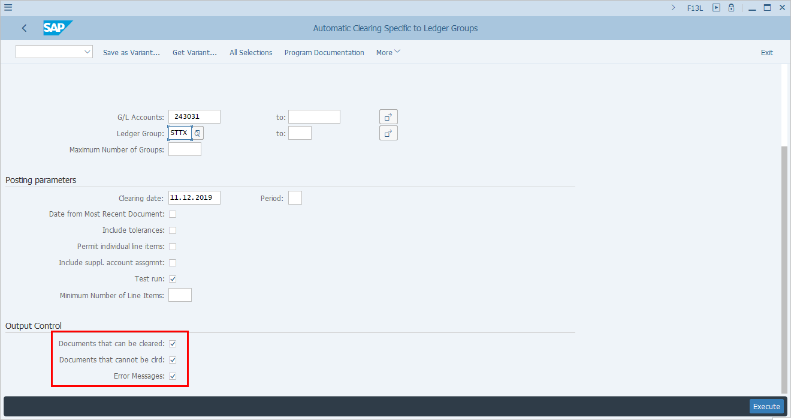
[14] Click Execute .  You can also press F8. | 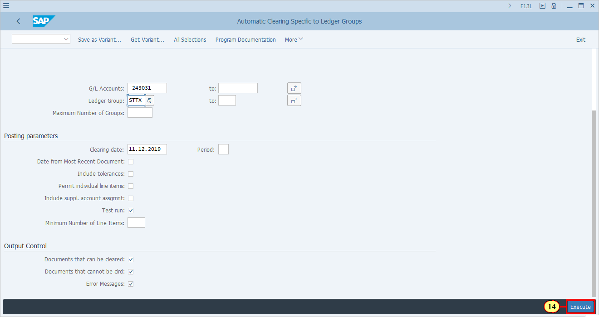
  For items which are selected but can't be cleared, they are shown with blank Clearing Date and Clearing Document.  You should also notice that column Ledger Group, which is based on your selection. | 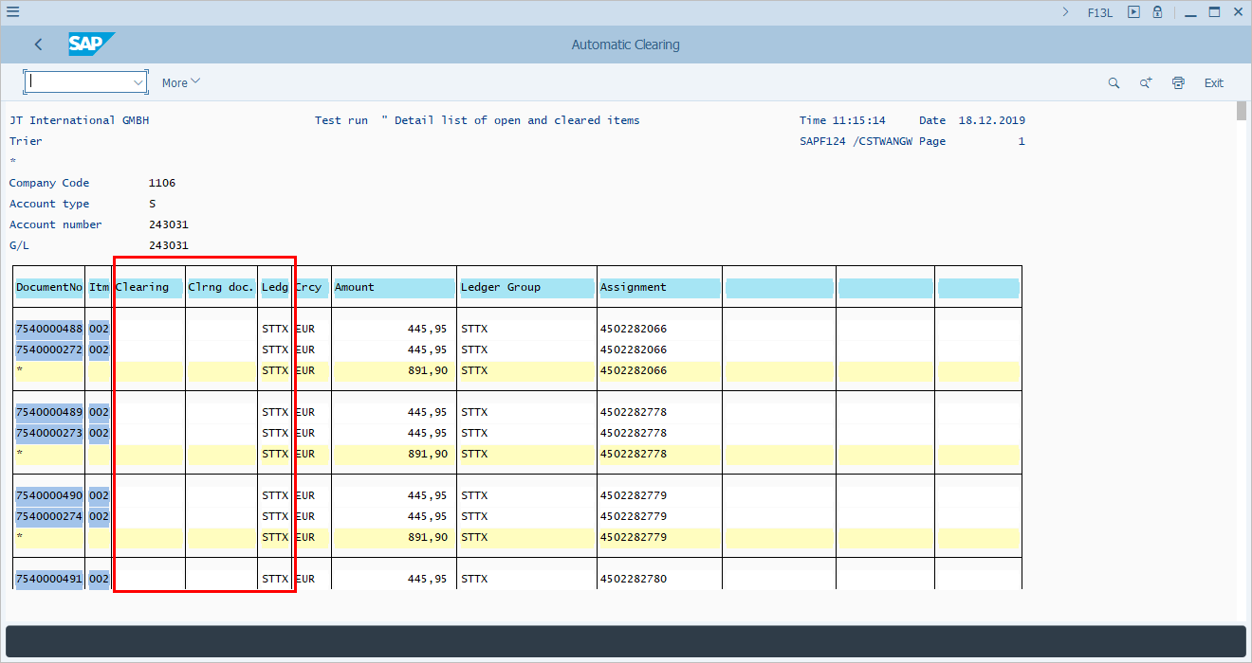
  For items which are selected AND can be cleared, they are shown with a Clearing Date. The Clearing Document column will be updated during the Update Run. | 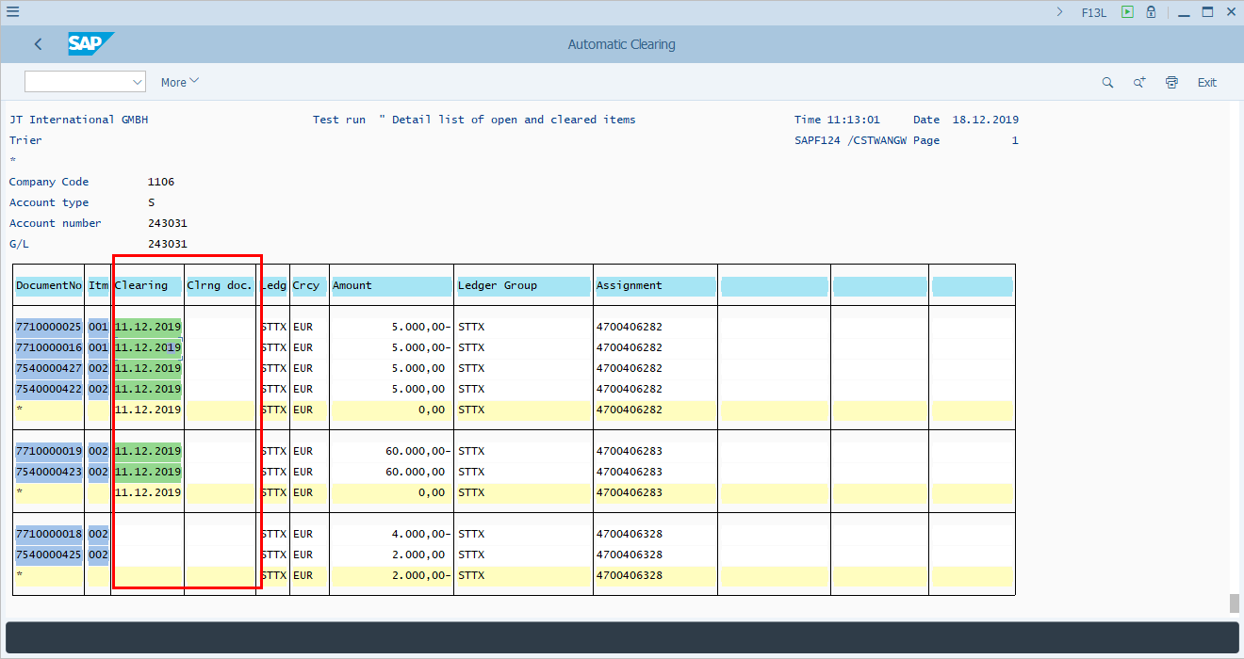
  You are advised to scroll to the bottom of the page to view the Error Log. If there's any error during Test Run you should fix the errors before executing the Update Run. | 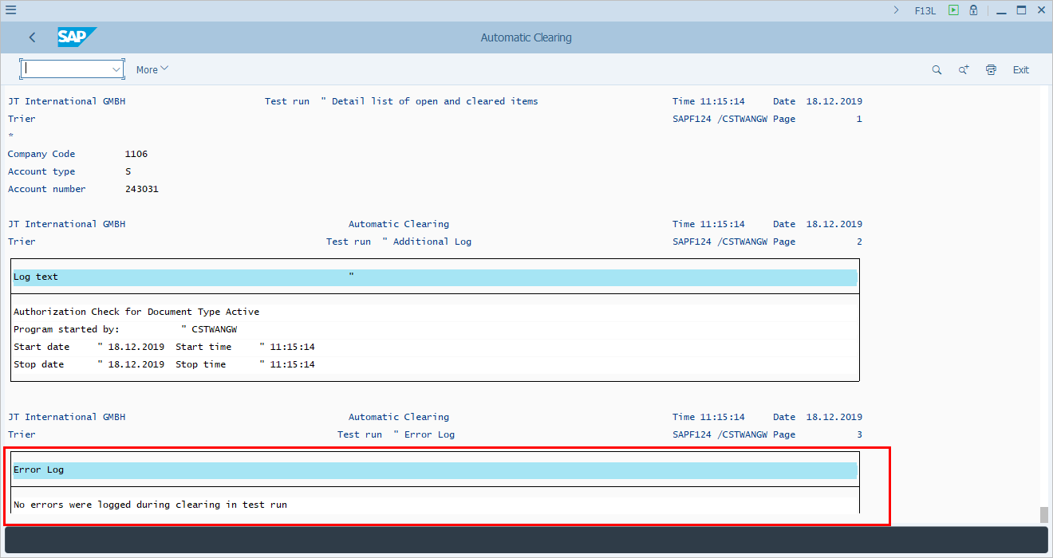
[15] Click Back to return to the selection page where you will be unticking the Test Run checkbox.  You can also press F3. | 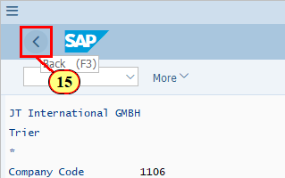
[16] Click Test run to remove the tick in the checkbox. | 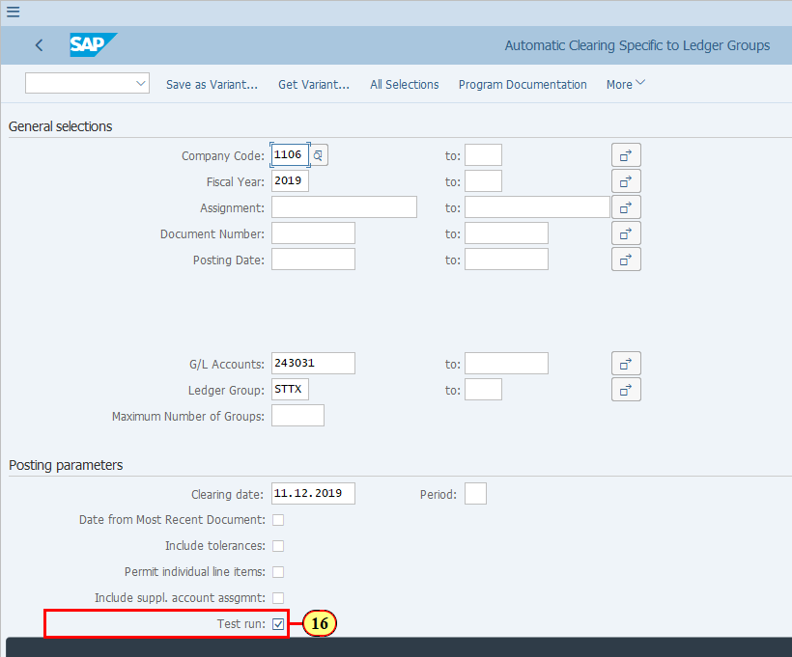
[17] Click Execute .  You can also press F8. | 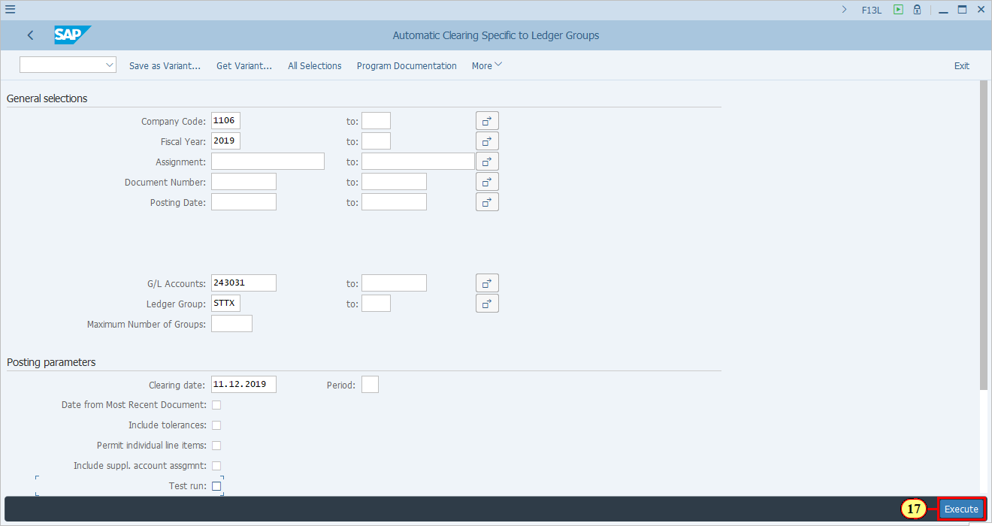
[18] If you receive warning message at the bottom of the screen, press ENTER to continue. | 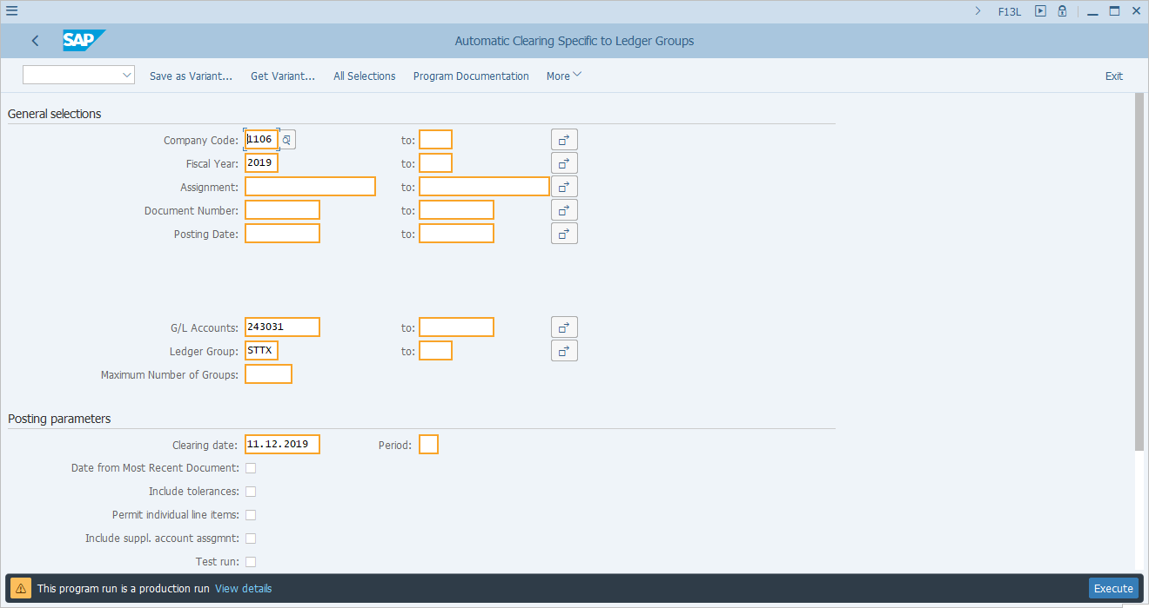
  If there's any error during update run, you can see these errors at the bottom of the page. | 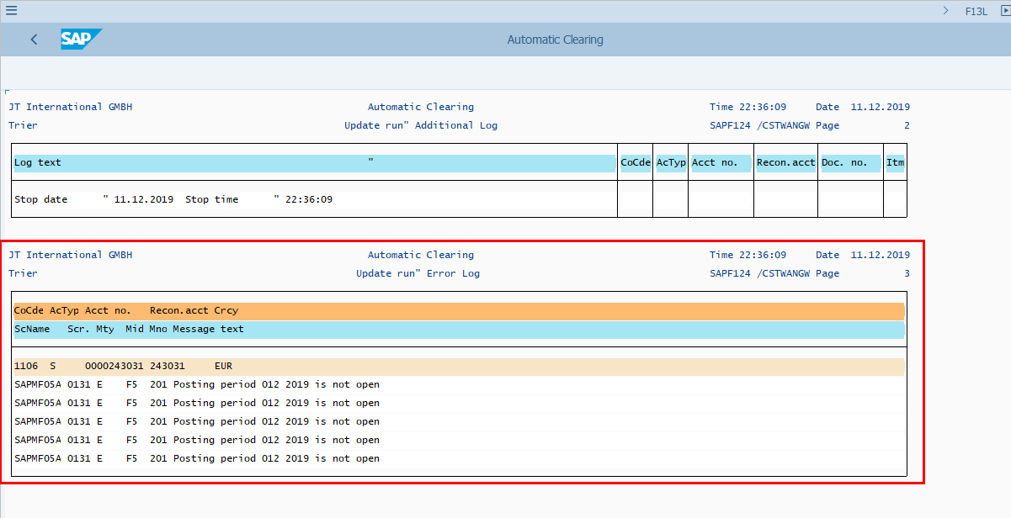
  If there's no error, you can see that the Clearing date and Clearing Document columnis updated during the Update Run.  You may copy the clearing document number for display via T-Code FB03. | 